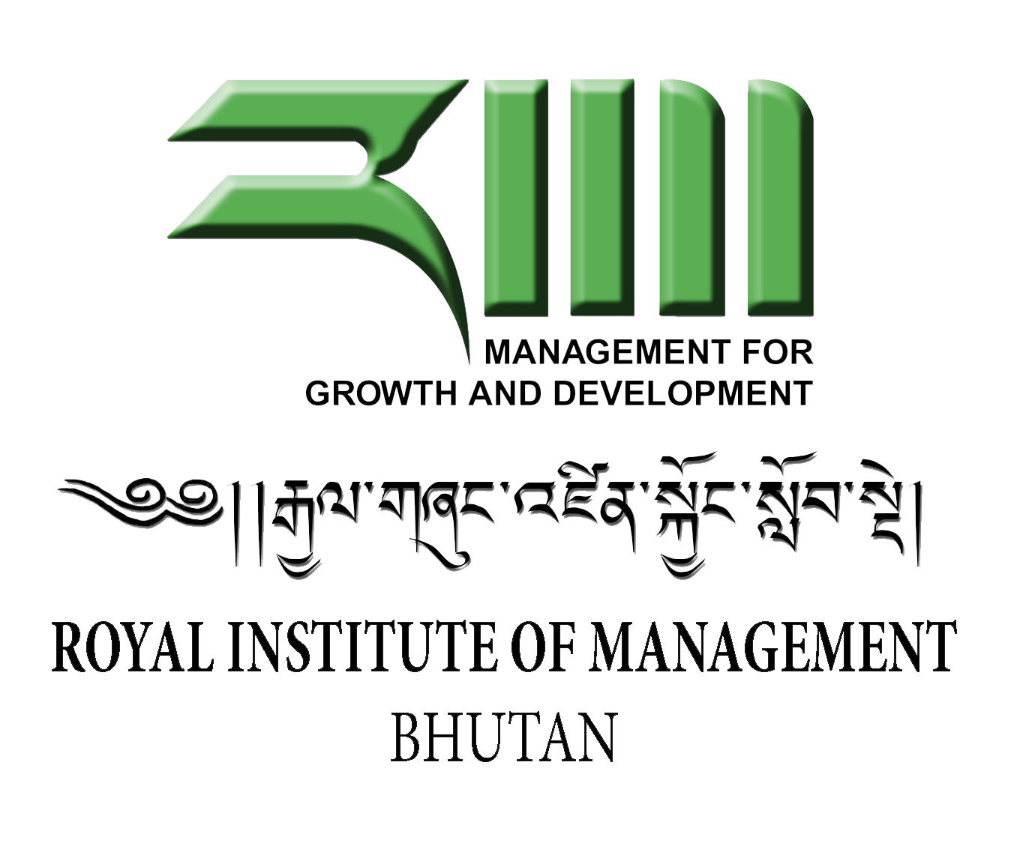

Unit Outline

Department/Centre: Department of Management Development

Unit title: Human Resource Management

(Nov, 2014)

This Unit Outline must be read in conjunction with RIM Academic Policy Handbook, which sets out Institute policies and procedures, including information on matters such as plagiarism, grade descriptors, moderation, feedback and deferred examination.
1: General Information

1a Teaching period and year offered: Term 3, 2014
1b Credit point value: 15 Credit Points
1c Unit level: Post Graduate
1d Name of Unit Convener and Course Coordinator and contact details (including telephone and email):

Unit Convener:
Dhanapati Mishra, Assistant Professor
Email: dhanapati_mishra@rim.edu.bt
Phone # 02 351013/351014 ext 172

Course Coordinator:
Chandra Kumar Kararia
Email:chandra_kumar_karariya@rim.edu.bt
Phone # 02 351013/351014

1e Administrative contact details (including name of the Program Assistant location, telephone and email)

Program Assistant:
Karma Tshomo
Program Assistant
Email: karma_tshomo@rim.edu.bt
Phone # 02 351013/351014
2: Academic Content

2a Unit description or syllabus

Human resources are strategic assets of organisations. The way these resources are managed determines, to a large extent, the success of organisations. As modern organisations are operating in a fluid and ever changing environments, successful administrators/managers must identify and implement creative ways to maximise performance of their employees in order to stay competitive and or give value for investments made to stakeholders. On such background, this unit is designed to provide students with requisite knowledge and build their skills so that they could critically analyse, develop and apply a range of people actions in their organizations to enhance and sustain their employees performance..
The unit covers the conceptual background to people management and discusses links between people management and organizational performance. In this context it discusses various people related strategies of resourcing, developing, rewarding, motivating and retaining. Further, it also provides opportunities to discuss key emerging people management issues and further discuss leadership challenges.

2b. Learning outcomes

At the end of the unit, participants will be able to:
- Articulate evolving concept of HRM and describe key models of strategic HRM.
- Critically analyse human resource management issues and their impact
- Apply knowledge and skills in context to solve emerging HRM issues
- Apply creative strategies to enable employees to continually adapt and change
- Synthesise key HRM functions to form wholistic approach to human resources management

2c. Graduate attributes developed in the unit

During the period of study, students shall have the opportunity to practice and develop the following employment skills:
- Professional skills: Plan, organise and prioritise work schedule and activities
- Information and Communication Skills: Locate, select, organize, document and process information using appropriate technology and sources and disseminate information thus derived in a suitable manner ;
- Cultural Understanding: Show respect for the diverse opinions, values, belief systems, and contributions of others;
- Leadership skills: Interact with others in groups or teams in ways that contribute to effective working relationships and the achievement of goals; and
- Thinking skills: Apply analytical skills to anticipate and solve complex problems
- Learning skills: Apply discipline knowledge learnt in context and to new situations

2d. Prerequisites and/or co-requisites

Conception of Organisational Behaviour is a pre-requisite to this unit

3: Delivery of Unit and Timetable

3a Delivery mode

This unit will be delivered in an intensive mode in Term 3. The sessions will comprise of lectures, case analysis, group discussions, presentations, learning from others experience, problem based learning, and independent studies. Students are expected to do all the readings prior to the attending the sessions each week. Besides, students are also expected to enhance their learning through collaborative work, online learning and self study. The timetable of learning activities is given in section 3b.

Students are required to attend all sessions. If the scheduled session falls on a public holiday or for unavoidable reason cannot be conducted as per the scheduled academic timetable, the unit convener in discussion with students will reschedule the session at a mutually convenient time.

3b Timetable of learning activities

Intensive Teaching Schedule: 24-28 November, 2014

Day 1

0900-0930: Introduction and Course Overview

Session 1: 0930-1100: Concepts and Significance of HRM: Lecture/Discussion
Session 2: 1130-1300: Strategic HRM: Lecture/Discussion
Session 3: 1400-1530: Issues in HRM: Group Discussions

Day 2
Session 1: 0930-1100: Recruitment and Selection: Case: Enterprise Rent a Car
Session 2: 1130-1300: Performance Management: Group Discussion
Session 3: 1400-1530: Issues in HRM : Group Discussion

Day 3

Session 1: 0930-1100 Training and Development: Group Discussion
Session 2: 1130-1300: Leadership and Management Development: Group Discussion:
Session 3: 1400-1530: Issues in HRM: Group Presentation- Group 1 and 2
Day 4
Session 1: 0930-1100: Employee Motivation: Case “Brent Templeton”
Session 2: 1130-1300: Managing Employee Organisational Relationship: Group Discussion
Session 3: 1400-1530: Issues in HRM: Group Presentation Group 3 and 4

Day 5
Session 1: 0930-1100: Video “Managing People Aspects of Organisational Change”: Group Discussion
Session 2: 1130-1300: Issues in HRM : Group Presentation Group 5
Session 3: 1400-1520: Best Practice Case: “How I learnt to let my Workers Lead”
Session 4: 1520-1530: Feedback/Evaluation

3c Required reading and other materials

All required readings and MS Powerpoint Presentations for each of the sessions will be uploaded in the RIM LMS Moodle. It will be available to the students one week before the commencement of the unit.

4: Unit Resources

4a Lists of required texts/readings

There is no standard Text Book for this unit. Minimum required readings and MS Powerpoint Presentations for each of the sessions will be uploaded in the RIM LMS Moodle. It will be available to the students one week before the commencement of the unit.

In addition students are encouraged to use the relevant Books and Journals from the Library and use the electronic databases that are available to supplement their reading.

4b Materials and equipment

All required materials and equipments will be made available for the sessions. Since reading materials are available through Institutes LMS Moodle, students are expected to have access to computer and internet so that they can access the unit reading materials which will be online.

4c Unit website
The unit materials can be accessed through institute’s Learning Management System (LMS) Moodle or alternately from the RIM website at inside Masters Programme..

5: Assessment

5a Assessment overview

Students will be assessed based on one Academic Essay, one Group Presentation on HR Proposal and a sit in examination of two hours, which will be conducted at the end of the term. Detailed description of the assessment items and assessment criteria is given in 5b). Students must complete ALL assessments and obtain a minimum of 50% in aggregate as reflected in the Academic Progress Policy to be eligible to pass the unit. The unit’s final grades/scores will be awarded in term of numerical figure where 100 being the maximum score.

All students are expected to adhere to the stipulated submission datelines. Late submissions, up to one week after the due date, will be entertained with 10 Marks penalty. Assignments submitted after that period will not be accepted, and it will be construed that it was not attempted. Students must be present in their groups for Group Presentations. Absence, with or without formal approval, shall be construed as not taking part in the assessment.

5b. Assessment item description including assessment criteria

b.1 Assessment 1: Academic Essay 2000 Words:

“Human resources, it has been argued, can constitute a particularly strong source of sustained competitive advantage, provided the firm is organized to exploit them”. Explain this statement and discuss managerial implications from HR perspective.

b.1a General guidelines on Assignment

- Assignment must be typed, using 1.5 spacing on one side of white A4 paper. Use Arial Font, size 12. Allow uniform margins on all sides of 2.5cm. Pages should be numbered accordingly except the title page.
- Cover page should indicate title of the essay followed by students number and date of submission
- Your essay should be within the word limit of 2000 words excluding title page,
- Use Harvard Anglia- 2008 referencing system. Errors in referencing will reduce your mark.
- All students are expected to adhere to the stipulated submission datelines. Late submissions, up to one week after the due date, will be entertained with 10 Marks penalty. Assignments submitted after that period will not be accepted, and it will be construed that it was not attempted
- Plagiarism is a serious offence. If there is a clear indication of breach of academic integrity, the assignment will be dealt as per the Academic Integrity Policy of the Institute.
- Work must be handed over in hard copy. A copy must be retained and should be made available on request.

b.1b Individual Written Assignment: Academic Essay 1500 Words- Marking Criteria

Assessment Areas | Marks
- Adequacy of discussion | 10 | 20
- Discussion of key managerial implications | 10
- Comprehensiveness- Does the essay include review of relevant seminal and/or current literature? – at least ten most important journal articles? |  | 7
- Logical structure of the essay at paragraph level  - Clarity of expression at sentence level  - Is the essay free from spelling, typographical and grammatical errors? | 1  1  1 | 3
Total |  | 30

b.2 Assessment 2: Group HR Proposal Presentation

Students in work groups choose any one of the emerging HR problems and develop HRM strategy to solve it. The group then presents the proposal to the stakeholders. Each group will have 20 min for presentation and 10 min for answering questions from the floor. Presentations will be done on the last three days of the teaching week. The working groups will be formed in the first day. Subsequently, there will be group discussions. Students are expected to come prepared beforehand for discussion.

b.2a General guidelines on Assignment

- Choose any HR related organizational problem (lack of employee motivation, high absenteeism, poor performance etc) which is common across the group
- Describe why is it a problem, how and why it might affect organizational goals
- Draw on theory and empirical evidence relating to this type of problem and its impact on individuals and organization at large
- Discuss what strategies could help solve the problem? Demonstrate how and why it could solve the problem.
- Discuss who will be affected by the solution and ways to tackle
- Prepare full implementation plan of the solution?
- Develop presentation materials
- Deliver presentation
- Conclude presentation with handing in a Written Synopsis of one page (two sides A4 paper)
Note:
  - Each group member will be given same marks.
  - Any group member absent during the presentation shall be given only half of the Marks obtained by the group.
  - All students are encouraged to sit through others presentation and ask questions and comment appropriate to the theme of presentation.

b.2b Group HR Proposal Presentation:- Marking Criteria

Group No : …………………………………………………………………………………………..  Names……………………………………………………………………………………………………………………………………………………………………………………………………….…………………………………………………………………………………………………………………………………………………………………………………………………………………………..) | Marks
Content  - Significance of the problem identified  - Discussion of the causes of the problems  - Quality of solution proposed  - Implementation plan  - Research evidence | 3  6  6  3  4 | 22
Delivery  - Quality of presentation Aids  - Time management  - Spread of delivery across members  - Handling questions | 1  1  1  1 | 4
Written Synopsis  - Structure and flow  - Clarity of expression  - Coverage of essential elements of proposal  - Correctness (Grammatical structures, typing errors stc) | 1  1  1  1 | 4
Total |  | 30

b.3 Term-End Examination (40)

There will be a two hour written examination at the end of the term. Students will be given questions on the topics/themes covered during the course. Students will be required to answer any two. Each question will carry equal Marks.

5c. Assignment due dates

Information about the assignments due dates and other additional information on assignments is as following:

Asessment form/method | Proportion of total Unit Marks | Due dates of submission | Penalties for late submission
Academic Essay | 30 | Dec 22, 2014 | 10 Marks for the first one week. Subsequently, assignments will not be accepted.
Group HR Proposal Presentation | 30 | As in schedule
Sit in Examination | 40 | Dec 22, 2014

5d. Weighting within the unit - to 100 per cent

The weightage given to each of the assessment type is as following

Assessment | Weightage
Academic Essay | 30%
Group HR Proposal Presentation | 30%
Term-End Examination | 40%

5e. Identification of the learning outcome/s the assessment item addresses

Assessment Items | Learning Outcomes addressed
Academic Essay | I, ii, v
Group HR Proposal Presentation | ii, iii, iv
Term-End Examination | I, ii, iii, iv, v

5f. Identification of the graduate attributes the assessment item addresses

Assessment Items | Graduate attributes addressed
Academic Essay | i,ii, v, vi
Group HR Proposal Presentation | i, ii, iii,iv,v
Term-End Examination | ii, v, vi
5g. Special assessment requirements—if any

None

5h. Supplementary assessment criteria

In normal circumstances supplementary assessment will not be entertained in any of the assessments mentioned in section 5b. Supplementary assessment may be granted in the circumstances pertaining to clause 9.1 & 9.2 of the Academic Progress Policy and carried out in accordance with clause 7 of the Examination Policy of the Institute.

5i. Requirements for academic integrity

Students are expected to be well versed with the Academic Integrity Policy of the Institute and any work/activities or assignment or assessments carried out as part of this unit has to be in line with the policy, especially clause 4. Failing to uphold the academic integrity in any forms will be dealt in accordance with the clause 5 of the Academic Integrity Policy of the Institute.

5j Text-matching software

There is no standard text matching software as such to detect plagiarism. However, random sample checks will be carried out of the works submitted. Defaulters will be penalized as per the provisions. Students, therefore, are advised to firstly make themselves familiar with various referencing systems, links to which are available in the Library and adhere to the policies and good practices of academic integrity and assist develop and promote this value.

6: Student Responsibility

6a Workload

Students are expected to work a minimum of 110 hours in addition to about 25 contact hours. This would be about the minimum required for standard pass grade. Students aiming to secure higher grades and those who are not familiar with the subject contents may need to commit additional time.

6b Special needs

This unit upholds and respects the Equity Policy of the Institute. A student with a disability, impairment, or medical condition who seeks reasonable adjustment in the teaching and learning or assessment methods in this unit on the basis of his/her disability may make request to the unit convener or course convener as soon as practicable after enrolment in the unit so that appropriate adjustments/arrangements can be made. Any such reasonable adjustments/arrangements must be agreed in writing between the student and the unit convener and must be in accordance with the related Institute policy.

6c. Attendance requirements

Each session is a critical link in the curriculum and missing a session creates a substantial gap in learning. Students, therefore, are advised to attend all the sessions. In the worst scenario, one must have 80% class attendance to be eligible for Term-End Examination. Failing which, one would be denied entry in the Term-End Examination and consequently have one form of assessments incomplete which would lead to failure of the unit.

6d Withdrawal

Withdrawal of candidature from this unit will be governed by the Academic Policy and other standing regulations of the government as may be relevant.

6e Required ICT skills

Students must have internet access. The unit outline, reading materials and lecture presentations will be uploaded in Institute’s LMS Moodle. All students must be familiar with using Moodle particularly being able to log in and make relevant use of materials provided there. Besides, students are also expected to be able to use the Microsoft Office package for their works. Students must also be able to connect to Institutes electronic Databases (PROQUEST, EMRALD Etc) and look up relevant materials. Students are encouraged to make use of IT Labs and Wireless Internet access which is available within the campus.

6f Costs

All required teaching/learning materials will be provided either as hard or soft copies. Students will have to bear expenses that may be required for additional copying book chapters, Xeroxing and/or making copies of additional materials.

6g Work Integrated Learning

Not applicable to this unit

6h Additional information

Additional information required for this unit will be delivered through Moodle. Students are advised to log in and check the weekly instructions in the unit schedule. Also students are advised to check in their Notice Boards for bulletins and news postings.

7: Student Feedback

Students have opportunity to provide anonymous feedback about the unit and the unit convener at the end of the term. This will be anonymous feedback which will be administered by the respective program assistant of the course. Students are requested to be candid about their views as this input will be taken into consideration for enhancing the curriculum, teaching learning methods in this unit and in developing technical competencies of the unit convener.

8: Authority of this Unit Outline

Academic Committee of the Institute approves all details related to this unit
This unit outline is based on the Institutes Academic Policy Handbook and its provisions on
- Course and Unit Specifications Policy
- Graduate Attributes Policy
- Academic Progress Policy
- Institutional teaching and learning policy
- Assessment Policy
- Examination Policy
- Credit Policy
- Academic Integrity Policy

