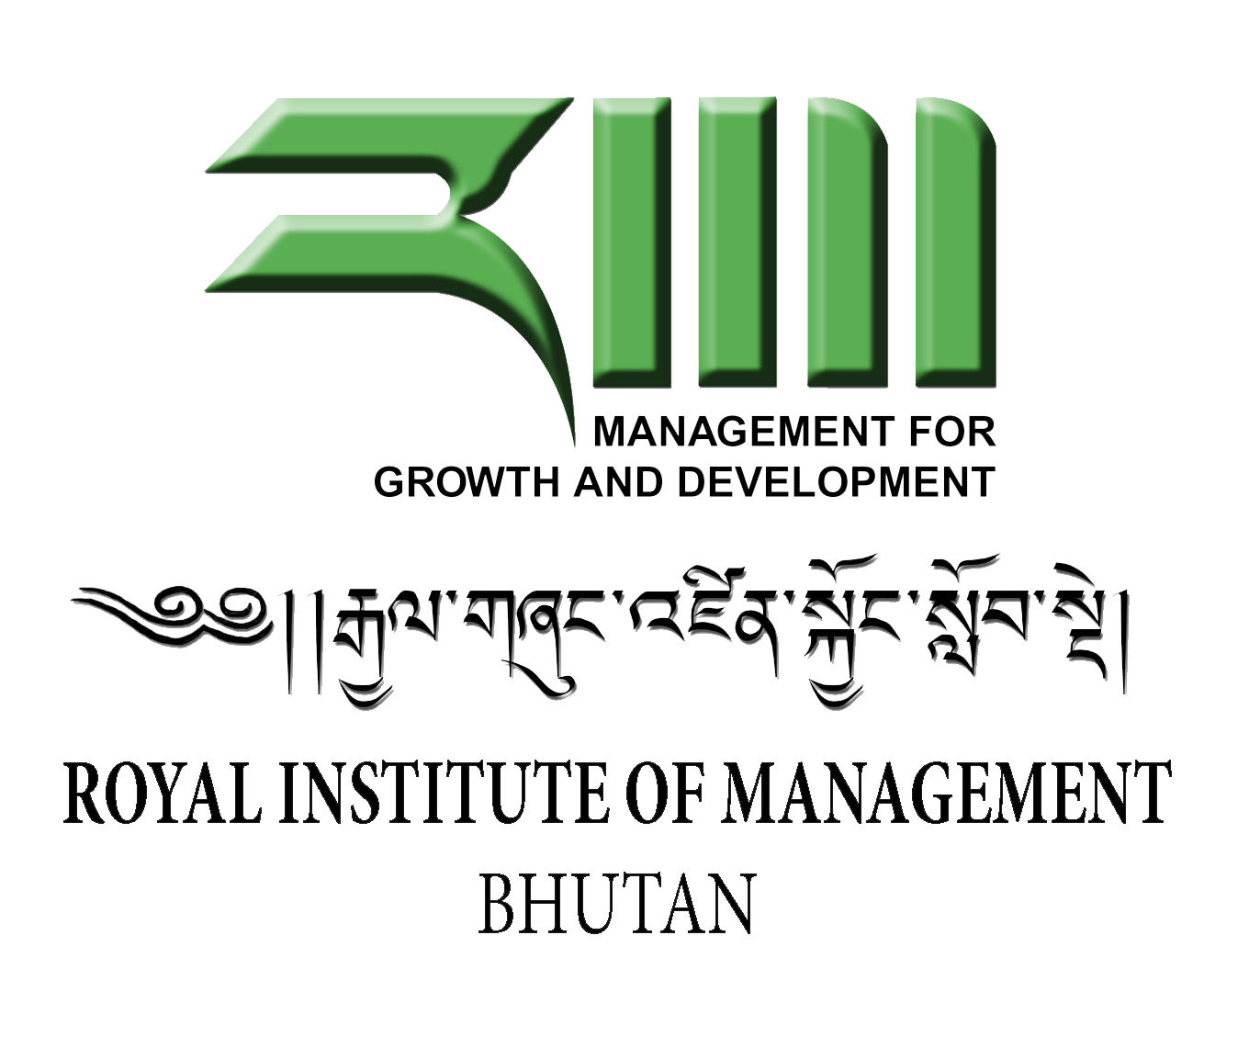
i

Unit Outline 2014
Department/Centre: Department of Management Development
Unit title: Introduction to Public Administration

This Unit Outline must be read in conjunction with RIM Academic Policies, which sets out Institute policies and procedures, including information on matters such as plagiarism, grade descriptors, moderation, feedback and deferred exams

1: General Information
1a Teaching period and year offered: 2014
1b Credit point value: 3
1c Unit level: Post Graduate Diploma
1d Name of Unit Convener and Course Coordinator and contact details (including telephone and email):
Unit Convener:
Indraman Chhetri
e-mail: indraman_chhetri@rim.edu.bt
Telephone No: 17606058

Course Coordinator
Chandra Kumar Krariya
Lecturer
Department of Management Development
Telephone No. 351013 Extension

1e Administrative contact details (including name of the programme assistant location, telephone and email)
Karma Tshomo
Programme Assistant
Department of Management Development
Telephone No. 351013 Extension 154

2: Academic Content

2a Unit description or syllabus
This unit focuses on concepts and issues relating to administration and management with particular focus on managing public organizations towards providing effective public service delivery. The unit includes the approaches to public administration, the role of the three branches of Government covering the role of the Executive Branch, the Legislature and the Judiciary, public goods and private goods, the distinction between public, private & Non-Governmental Organizations (NGOs), different approaches to management and their relevance in public administration/management, Organization and its Fit, Transition in public administration including public administration/civil service reforms in selected countries, public service delivery models and mechanism, law and public administration and Ethics and Public Accountability.

This module is designed to encourage participants to develop:

- an advanced knowledge of public administration to prepare students for roles as future administrators and managers of complex public organizations;

- managerial and leadership skills to manage and lead organizations;

- an understanding of key developments and issues in public administration emerging internationally and capacity to relate these to public administration in Bhutan; and

- capacity for in-depth and original responses to unpredictable problems and situations.

2b. Learning outcomes

At the end of the module, participants will be able to:

- understand the functioning of public administration from broad international perspectives

- develop knowledge of contemporary issues in governance, management, administration;

- inject innovative and effective skills and knowledge into the management and leadership of public organizations;

- contribute to improved management practices in the public sector based on the need of the country and taking into account the lessons from other countries; and

5. develop a continuing interest in issues which impact on public administration.

2c. Graduate attributes developed in the unit

The unit is expected to develop the following attributes among the graduates:
1. Analytical and problem solving skills (by using given frameworks, skills and techniques)
2. Presentation and communication skills (through case discussions, class participations and presentations)
3. Sensitivity and awareness to public administrative issues
4. Managerial and leadership skills
5. Accountability to Self and Others

2d. Prerequisites and/or co-requisites
No prerequisites are necessary for this course

3: Delivery of Unit and Timetable

3a Delivery mode
There will be 5 days of classes including one day of presentations and discussions. Class hours will be from 09300-1230 pm and 1.30pm to 430pm. Delivery will comprise of lecture component, presentations, and group discussions.

3b Timetable of learning activities
Day | Topic | Methodology | Reading Materials
DAY 1  SESSION 1  To understand the objectives and expectations of the course  SESSION 2  To understand perspectives of public administration and analyze the pros and cons of each | INTRODUCTION  Briefing on the course objectives, assignments and evaluation  INTRODUCTION AND APPROACHES TO PUBLIC ADMINISTRATION  Introduction to Public Administration  Managerial Approach  Political Approach  Legal Approach | Lecture  Discussion: “Which approach do you think could the best approach and why? | Introduction: The Role of Public  Administration in Governing  - B . G u y P e t e r s and J o n P i e r r e  Rosenbloom page 13-27
SESSIONS 3-4  To understand the importance of State and Government | THE STATE AND GOVERNMENT  The Role of the State  What does Public Sector/Government do? | Lecture and discussions | Hughes, Chapter 4 “The Role of Government”
DAY 2  SESSION 1-4  To introduce the evolution of management thoughts and equip the participants with basic functions of management | MANAGEMENT  The Evolution of Management Thoughts.  Different approaches to management  Leaders and Managers | Lecture and Discussions | Refer:  Robbins and Coulter, Part I
DAY 3  SESSION 1-2  To develop system approach in the decision making and strategic formulation process | System Theory to Management  Environment Assessment | Lecture and Discussions | Environment assessment Tools
DAY 3  SESSION 3-4  To acquaint the participants on the critical role of State Bureaucracy | The Role of Bureaucracy in Public Service Delivery | Lecture and discussions | Ferlie, E, Lynn L E. & Pollitt, C (2005), “Bureaucracy in the 21st Century”, Chapter 3.
DAY 4  SESSION 1-2  To understand the importance of constitution, democracy and separation of power | CONSTITUTION, DEMOCRACY AND SEPARATION OF POWERS | Lecturer and Discussions | Power point presentation notes
DAY 4  SESSION 4-5  To explore emerging issues that are or will be facing the public services worldwide and critically assess these contemporary issues as they might apply to Bhutan | PARADIGMS IN PUBLIC ADMINISTRATION AND MANAGEMENT  Traditional Public Administration Model, New Public Management (NPM) and Governance Model and its implications on the service delivery | Lecture/ discussions | Hughes, Chapter 3, “Public Management”  Polya Katsamunska, ‘Classical and Modern Approaches to Public Administration’ – Article  Gernod Gruening, “Origin and theoretical basis of New Public Management”, International Public Management Journal 4 (2001) 1–25
DAY 5  SESSIONS 1-4  Participants are able to apply knowledge and skills of management/public administration in solving selected public issues/problems | PRESENTATIONS AND DISCUSSIONS OF KEY PUBLIC ISSUES | Presentations of different topics by the students on emerging public issues facing Bhutan | As per the given guideline  (Appropriate date shall be fixed for the presentation)

3d Required Reading:

As given above under 3c

4: Unit Resources
4a Lists of required texts/readings
Hughes, Owen E (2005) (4th Edition), Public Management and Administration: An Introduction, Palgrave Macmillan, New York

Ferlie, E, Lynn L E. & Pollitt, C (2005), The Oxford Handbook of Public Management, Oxford University Press, Oxford (Main text book of this course)
Feigenbaum, H, Henig J & Hamnett, C Shrinking the State, Cambridge University Press, Cambridge
Gormley, W (1994) Privatization Revisited, Policy Studies Review, Autumn/Winter, 13 (3/4)

Gunn, L (1992) ‘Perspectives on Public Management’ in Kooiman, J & Eliasson, K Managing Public Organisations: Lessons from Contemporary European Experience, Sage, London

Hatch, M Jo (1997), Organization Theory, Oxford University Press, Oxford

Pollitt, C (2003) The Essential Public Manager, Open University Press, Maidenhead.

Robbins, S P. and Coulter, M (1998), Management, Prentice-Hall of India, New Delhi

Rosenbloom, D H (1988), Public Administration: Understanding Management, Politics and Law
in the Public Sector, Random House, New York

4b Materials and equipment
In order to deliver the unit effectively, the following materials & equipment are required:
Chart papers – 100 pieces
Markers – 25 Nos
While Boards – 2 Nos
LCD projector – 1 No.
White Screen – 1 No.
Computer (laptop/desktop) – 1 No

4c Unit website
5: Assessment
Moodle is under construction now.

5a Assessment overview
Assessment shall comprise of presentation, written assignment, final examination and class participation.

5b. Assessment item description including assessment criteria
The following assignments/examinations shall be used to compute final grade:
Assignment 1: Presentation (35 Marks)
Students can work in a group of maximum five and select any topic on emerging issues of public administration in Bhutan, eg. Public service delivery, the role of bureaucracy in Bhutan, NGOs and their roles in Bhutan, good governance/e-governance, GNH, public accountability, financial accountability, ethics and integrity in the public service, etc. The proposal must be presented in the class with the scheduled date as announced by the lecturer and endorsed before undertaking the proposed study. Presentation is usually done towards the last phase of the classes as announced by the lecturer. Presentation must be done on Microsoft office PowerPoint and write-up must be submitted one day ahead of the presentation.

Assessment criteria:
- Presentation shall be evaluated using the following criteria:
- Clarity on the objectives of the paper and issues/problems highlighted for the study -5 marks
- Comprehensiveness of Literature Review – 10 marks
- Clarity of Analysis – 10 marks
- Recommendations – 5 marks
- Overall presentation – clarity, visibility, confidence, professionalism, etc) - 5

Besides analyzing topics on issues of public concern, students will be asked to integrate the overall knowledge of public administration and present holistic view on the chosen topic.

Assessment 3: Final Examination (60 Marks)
Final exam will be based on critical reasoning and justifications that students have to provide for the statements. For every statement, response could be either “True”, “False” or “Neither True Nor False”. Then, students have to give justifications for their response. No marks will be awarded if the justification is wrong or not clear.

Class participation/contribution (5 Marks)
Participation of students during case discussions and other required readings will be noted and recorded for assessment.

Assignment 1: Presentation (15 Marks)
Students can work in a group of maximum five and select any topic on emerging issues of public administration in Bhutan, eg. Public service delivery, the role of bureaucracy in Bhutan, NGOs and their roles in Bhutan, good governance/e-governance, GNH, public accountability, financial accountability, ethics and integrity in the public service, etc. The proposal must be presented in the class with the scheduled date as announced by the lecturer and endorsed before undertaking the proposed study. Presentation is usually done towards the last phase of the classes as announced by the lecturer. Presentation must be done on Microsoft office PowerPoint and write-up must be submitted one day ahead of the presentation.

Assessment criteria
- Presentation shall be evaluated using the following criteria:
- Clarity on the objectives of the paper and issues/problems highlighted for the study -2 marks
- Comprehensiveness of Literature Review – 3 marks
- Clarity of Analysis – 5 marks
- Targeted, internationally referenced and innovative recommendations – 2 marks
- Overall presentation – clarity, visibility, confidence, professionalism, etc) - 3

Besides analyzing topics on issues of public concern, students will be asked to integrate the overall knowledge of public administration and present holistic view on the chosen topic.

Assignment 2: Written Assignment (40 marks)
Written assignment shall be carried out individually by the student. Under this assignment, students will be asked to review the emerging the role of state bureaucracy of Bhutan, document literature on the practices of other countries, analyze & discuss and make appropriate recommendations to improve the effectiveness of the bureaucracy.

Evaluation of the paper shall be done based on the following criteria:

Clarity on the background of the public administration issue – 5 marks
Comprehensiveness of literature review - 10
Depth of analysis and discussions - 20
Quality of recommendations – 5

GENERAL GUIDELINES FOR ASSIGNMENTS

Detailed guidelines for each assignment shall be discussed in the class. Participants are also requested to get clarification from the concerned lecturer on any assignment.

Assignment Title and Assignment Number must be clearly mentioned on the cover page.

Length of one assignment paper must not exceed 5 pages (1.5 spaced) excluding title and reference page.

Font: 12 Arial

Margins: Top – 1”; bottom -1”, left-1.25” and right 1.25”

Assignment paper must be submitted in hard and soft copies. Soft copy can be e-mailed to: indraman_chhetri@rim.edu.bt

Penalties shall be imposed for late submission

Note: Soft copy of the assignments must be maintained by the trainees till the time the evaluation m

5c. Due dates
- Date for presentation will be announced

- Final Examination is conducted during the Examination Week o(as scheduled)

5d. Weighting within the unit - to 100 per cent

Presentation: 35 marks

Final Examination: 60 marks

Class participation/contribution: 5 marks

5e. Identification of the learning outcome/s the assessment item addresses

Assessment Items | Learning Outcomes (Refer 2b for details of outcomes) | Remarks
Presentation Paper | 1,2,3,4,5,6 | Students are asked to present holistic view of the chosen topic and therefore covers all the outcomes of the unit
Final Examination | 1,2,3,4,5,6
Class Participation/contribution | 1,2,5,6

5f. Identification of the graduate attributes the assessment item addresses

Assessment Items | Graduates’ attributes (Refer 2c for details of graduates’ attributes) | Remarks
Presentation | 1,2
Written Assignment | 1,2,3,4,5
Class Participation/contribution | 1,2,5

5g. Special assessment requirements—if any
Not Applicable here

5h. Supplementary assessment criteria
As per Academic Policy

5i. Requirements for academic integrity
Students are expected to be well versed with the Academic Integrity Policy of the RIM and standing rules and regulations on Plagiarism.
Students have a responsibility to uphold ethical values on all matters.
Cheating, plagiarism, and falsification of data are dishonest practices that contravene academic values and professionalism.

5j Text-matching software
Appropriate software or other means may be used for purposes of detecting plagiarism or unethical behavior among students.

6: Student Responsibility

6a Workload
Students will be required to put in at least 150 hours of work including the class time and preparatory works. Students who do not have adequate background in public administration/management will be required to spend more time than 150 hours for the unit.

6b Special needs
Students with special needs due to disability or due to other circumstances should inform their Unit Convener well in advance so that appropriate arrangements can be made

6c Attendance requirements
Students are required to maintain 80% of attendance in the unit failing which they will not be allowed sit for the final examinations. Further, final marks will not be declared if the students do not meet the attendance requirement

6d Withdrawal
Withdrawal from the Unit will be governed by the Academic Rules and Regulations of the RIM

6e Required IT skills
Students must possess basic IT skills including the skills to use Microsoft Office Word, Microsoft Office Excel, and Microsoft Powerpoint including the skills to use internet

6f Costs
All costs related to the scholarship of the course/unit will be borne by the Royal Government of Bhutan except where specified otherwise. For example, student will have to buy their own stationeries or pay for reproduction costs beyond a certain limit.

6g Work Integrated Learning
Not Applicable

6h Additional information
As may be announced by the course coordinator and unit convener from time to time

7: Student Feedback
All students enrolled in this unit will have an opportunity to provide anonymous feedback on the unit at the end of the Semester via the Unit Feedback Survey (USS).

8: Authority of this Unit Outline
This unit outline is prepared based on the:
- Credit Policy
- Institutional teaching and learning policy
- Graduate Attributes Policy
- Academic Progress Policy
- Assessment Policy
- Course and Unit Specifications Policy
The contents of the Unit is also benchmarked with the similar Unit offered in the University of
Canberra, Australia (based on the validation exercise carried out during 2007/2008).
Changes in the contents of this Unit will be governed by the Academic Rules and Regulations of the RIM

Any change in the contents of this Unit is subject to Academic Rules and Regulations of the RIM.

