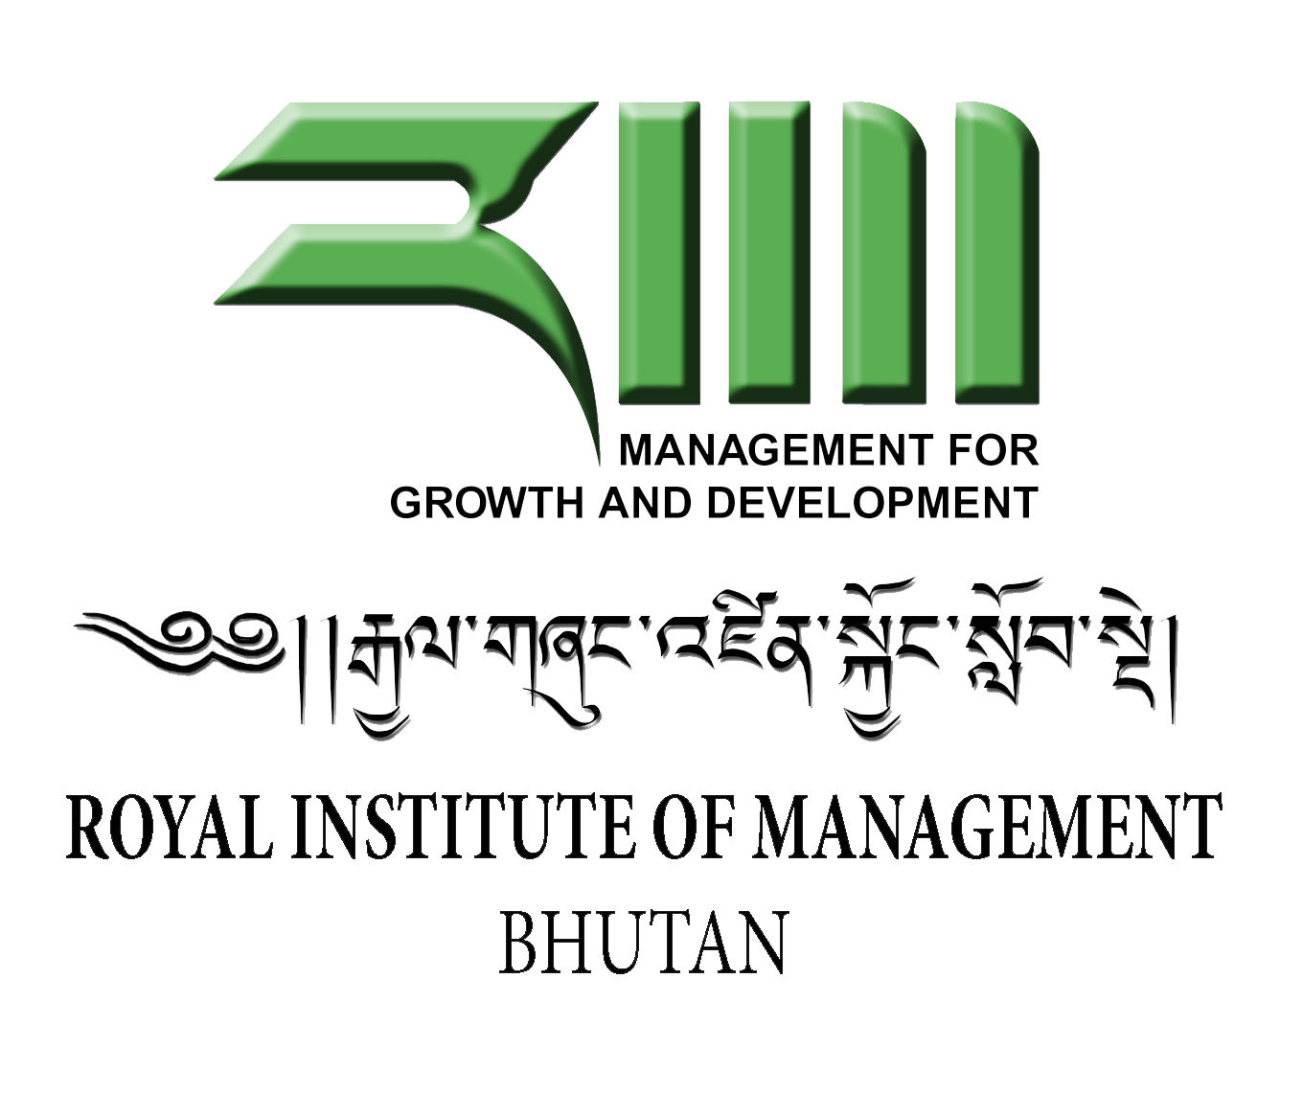

Unit Outline 2016 (MBM)
Department: Department of Management Development (DMD)
Unit title: Human Behaviour in Organisation (HBO)/Organisational Behaviour (OB)
Unit reference code:

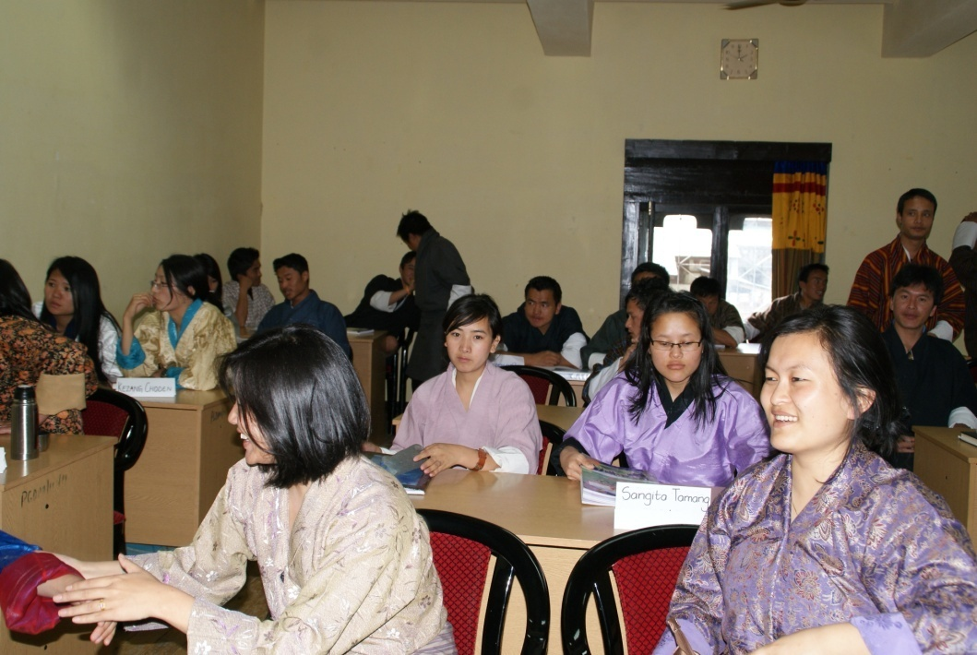

This Unit Outline must be read in conjunction with RIM Academic Policies, which sets out Institute policies and procedures, including information on matters such as plagiarism, grade descriptors, moderation, feedback and deferred exams

1: General Information
1a Teaching period and year offered: 2016
1b Credit point value: As per UC standard.
1c Unit level: Masters
1d Name of Unit Convener and Course Coordinator and contact details (including telephone and email):
Unit Convener:
Thinley Namgyal
Associate Professor/Registrar
Email: thinley_namgyal@rim.edu.bt
Phone # 02 351013/351014

Course Coordinator

Phuntsho Rinzin
Assistant Planning Officer
Email:phuntsho_rinzin@rim.edu.bt
Phone # 02 351013/351014

1e Administrative contact details (including name of the programme assistant location, telephone and email)

Karma Tshomo
Programme Assistant
Email: karma_tshomo@rim.edu.bt
Phone # 02 351013/351014

2: Academic Content

2a Unit description or syllabus
Organisational Behaviour (OB) is the systematic study of human behaviour at the individual, group and organisational levels. The primary purpose of this unit is to develop an understanding of the management of modern organisations through knowledge of human behaviour. An understanding of human behaviour is needed to establish and maintain productive working relationships both within the organisation (superiors, peers, and subordinates) and outside the organisation (customers, suppliers and competitors). In order to establish and maintain these relationships managers must be able to understand the behaviour of others, predict it and influence it.

The topics set forth in the study schedule begin with a focus on the individual analysis of behaviour characterised by factors such as perception, attitudes, personality, learning, and motivation. These topics are central to understanding individuals both as employees and as consumers. Next, the analysis of behaviour at the group level examines culture, leadership, the dynamics of group processes, and ethics. Finally, topics covered at the organisational level of analysis include the distribution of power, the impact of politics, conflict management and processes involved in organisational change and development. Change has become a major issue in the past decade. Many firms have eliminated levels of management to form a lean, flexible, adaptive form in order to respond to the ever increasing demands of the competitive global marketplace.

It is hoped that through your active participation in this unit you will gain a rounded appreciation of factors that influence success in work environment and marketplace both locally and internationally.

2b. Learning outcomes
At the end of the module, participants will be able to:

- Adjust in the new workplace in a changing work environment.
- Understand the individual attitudes, perceptions and values that affect the workers performance.
- Able to work as a team in the work place.
- Manage and resolve conflict within an organization.
- Manage, motivate and lead an organization.
- Understand and be ethical and accountable to self and others

2c. Graduate attributes developed in the unit
The unit is expected to develop the following attributes among the graduates:
1. Analytical and problem solving skills
2. Presentation and communication skills
3. Professionalism and social responsibility
4. Managerial and leadership skills
5. Ethical values and Accountability

2d. Prerequisites and/or co-requisites
Not relevant

3: Delivery of Unit and Time table

3a Delivery mode

There will be a total of 5 days class. Delivery will comprise of lecture, group work and presentations. Since it is a student centre learning students are encourage to take active part in group discussion and independent study. The learning environment will be enhanced by good library and technology enabling learning.
Students should go through the handouts and other resource materials to actively take part in discussion and learning.

3b. Timetable of learning activities
Sessions/Dates | Topic | Methodology | Reading Materials
Sessions 1 – 7  15th Feb. 2016  . | 1. What is organisational behaviour?  2. Diversity in organizations.  3. Attitude and job satisfaction. | Lecture, discussion, and group work: | Text book “Organisational Behaviour” 8th edition, Stephen P. Robbins and  “Organisational Behaviour” 7th edition, Robin, Judge, Millett, Boyle.  Group work: “My Best Manager.”
Sessions 8 – 14  16th Feb. 2016 | 1. Personality and values.  2. Emotions and moods.  3. Perception and individual decision making.  4. Motivation. | Lecture, discussion, and group work: | Read the chapters from both text books.  Group work “Crocodile River Story.”
Sessions 15 – 22  17th Feb. 2016 | 1. Group  2. Team  3. Communication. | Lecture, discussion, and group work: | Read the chapters from both text books.  Group work: “The Island.”
Sessions 23 – 32  18th Feb. 2016 | 1. Leadership.  2. Conflict.  3. Negotiation. | Lecture, discussion, and group work: | Read the chapters from both text books.  Exercise: “Moon explorer problems.”
Sessions 33 – 39  19th Feb. 2016 | 1. Organisational design.  2. Organisational structure.  3. Organisational culture. | Lecture, discussion, and group work: | Read the chapters from both text books.  Group presentation

4: Unit Resources

4a Lists of required texts/readings
Gary Johns, Alan M. Saks, 2008. Organizational behaviour: Understanding and
managing at work
John Adair, 2008. Leadership and motivation: The fifty-fifty rule and the eight key principles of motivating others.
Jackson, N. & Carter, P. 2007. Rethinking Organisational Behaviour: A Postructuralist Framework. Harlow: Prentice Hall.
Jick, T.D. 1993. Managing change: Cases and concepts. Chicago: Irwin.
Johns, G. 1996. Organizational behavior (4th ed.). New York: Harper Collins.
Konopaske, R. & Ivancevich, J.M., 2004. Global management and organisational behaviour. Boston: McGraw Hill.
Kreitner, R. & Kinicki, A. 2004. Organisational behaviour (6th ed.). Chicago: Irwin McGraw Hill.
Luthens, F. 1995. Organisational behaviour (7th ed.). New York: McGraw Hill.
McShane, S. (2005). Organisational behaviour on the Pacific rim. North Ryde, McGraw-Hill.
McShane, S.L. & Von Glinow, M A. 2003. Organizational behavior (2nd Ed). Boston: Irwin McGraw Hill.
Moorhead, G., & Griffin, R.W., 1998. Organizatioal behavior (5th ed.). Boston: Houghton Mifflin.
Mullins, L. J. (2005). Management and organisational behaviour. London, Prentice Hall.
Ott, J. 1996. Classic readings in organisational behaviour. Belmont: Wadsworth.
Robbins, S.P., Millet, B., & Waters-Marsh, T., 2004. Organisational Behaviour. (4th ed.). Sydney, Prentice Hall.
Schermerhorn, J., Hunt, J. & Osborn, R., 1997. Managing organisational behaviour (6th ed.). New York: Wiley & Sons.
Steers, R., Porter, L. & Bigley, G., 1996. Motivation and leadership at work (6th ed.). New York: McGraw-Hill.
Wagner, J. & Hollenbeck, J., 1998. Organizational behaviour securing competitive advantage (3rd ed.). Englewood Cliffs, New Jersey: Prentice Hall.

4b Materials and equipment
In order to deliver the unit effectively, the following materials & equipment are required:
Transparency sheets – 1pkt
Markers –10Nos
OHP - 1
While Boards–2 Nos.
LCD projector – 1 No.
White Screen – 1 No.
Computer (laptop/desktop) – 1 No

4c Unit website
Moodle

5: Assessment

5a Assessment overview
Assessment shall comprise of class participation, presentation, group assignment, and final examination.

5b. Assessment item description including assessment criteria
The following assignments/examinations shall be used to compute final grade:

Assignment 1. Class participation (5 marks):
Students will be given 5 marks for class participation (questions, answers, sharing experiences and etc).

Assignment 2. Group work and presentation (5 marks):
Students will be assessed on group work. Groups will comprise of six to seven members and marks will be awarded as per below mentioned criteria.

Assessment criteria
Presentation shall be evaluated using the following criteria:

- Overall presentation of individual-(2 mark).
- Clarity, analysis and Q & A of the group-(3 mark).

Assignment 3. Group Assignment (30 marks): Group comprising of six to seven members will select a country or more than two countries that are having conflict. The group as negotiators must resolve the conflict by applying the knowledge and skills learned in class/out-side.

Assessment criteria
Presentation shall be evaluated using the following criteria:

- Introduction-(5 marks)
- Application of knowledge and skills-(15 marks)
- General presentation and Q & A of the group-(10 marks).

Assignment 4. Examination objective type questions (60 marks). Time allotted is 2 hours.

5c. Due dates
- Presentation will be conducted on the 5th, day that is on Feb. 19th, 2016 at 2.00 pm.

- Final date of examination will be conducted as the RIM Calendar of Events.

5d. Weighting within the unit - to 100 per cent
Class participation 5 marks

Group work and presentation 5 marks

Group Assignment 30 marks

Multiple choice questions 60 marks

5e. Identification of the learning outcome/s the assessment item addresses

Assessment Items | Learning Outcomes (Refer 2b for details of outcomes) | Remarks
Class participation | 1,2,3,4,5,6
Group work and presentation | 1,2,3,4.5,6
Group Assignment | 3,4
Multiple choice questions | 1,2,3,4,5,6

5f. Identification of the graduate attributes the assessment item addresses

5f. Identification of the gradutes attributes the assessment item addresses

Assessment Items | Graduates’ attributes (Refer 2c for details of graduates’ attributes) | Remarks
Class participation | 1,2,3,4,5.
Group work and presentation | 1,2,3,4,5.
Group Assignment | 1,2.
Multiple choice questions | 1,2,3,4,5.

5g. Special assessment requirements—if any
Not applicable here

5h. Supplementary assessment criteria
Not applicable here

5i. Requirements for academic integrity
Students are expected to be well versed with the Academic Integrity Policy of the RIM and standing rules and regulations on Plagiarism. Link to url?
Students have a responsibility to uphold ethical values on all matters.
Cheating, plagiarism, and falsification of data are dishonest practices that contravene academic values and professionalism.

5j Text-matching software
Appropriate software or other means may be used for purposes of detecting plagiarism or unethical behavior among students.

6: Student Responsibility

6a Workload
Students will be required to work hard to successfully complete the units. They will also in preparation for the unit read the required materials, cases, text books, journals, group discussions, data collection, etc.
Students who do not have adequate background in organizational behavior/management will be required to spend more time than others.

6b Special needs
Students with special needs due to disability or due to other circumstances should inform their Unit Convener well in advance so that appropriate arrangements can be made

6c Attendance requirements
Students are required to maintain 80% of attendance in the unit failing which they will not be allowed sit for the final examinations. Further, final marks will not be declared if the students do not meet the attendance requirement

6d Withdrawal
Withdrawal from the Unit will be governed by the Academic Rules and Regulations of the RIM

6e Required IT skills
Students must possess basic IT skills including the skills to use Microsoft Office Word, Microsoft Office Excel, and Microsoft PowerPoint including the skills to use internet

6f Costs
All costs related to the scholarship of the course/unit will be borne by the Royal Government of Bhutan except where specified. For example, student will buy their own stationeries or pay for reproduction costs beyond a certain limit.

6g Work Integrated Learning
Not Applicable

6h Additional information
As may be announced by the course coordinator and unit convener from time to time

7: Student Feedback
All students enrolled in this unit will have an opportunity to provide anonymous feedback on the unit at the end of the Semester via the Unit Feedback Survey (USS).

8: Authority of this Unit Outline
Academic Committee approves all details related to this unit
This unit outline is based on the
- Credit Policy
- Institutional teaching and learning policy
- Graduate Attributes Policy
- Academic Progress Policy
- Assessment Policy
- Course and Unit Specifications Policy
The contents of the Unit is also benchmarked with the similar Unit offered in the University of Canberra, Australia (based on the validation exercise carried out during 2007/2008).
Changes in the contents of this Unit will be governed by the Academic Policies of the RIM.

